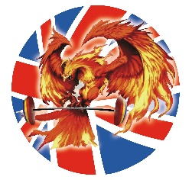
Code of conduct for Stars for the future weightlifting club
Club rules for under 18 and over 18
- They should follow the training programme
- Attend regular training sessions and must be on time
- Respect for individual coaches (race, colour and religion)
- Respect individual club members including team mates, anti-social or abusive behaviour will not be tolerated.
- Have to be civil with each other
- Should be honest and trustworthy
- During competition time must always be with the team and can only leave when accompanied by an over 18 year old.
- Lifters under 18 must be supervised at all the times by coach.
- Correct footwear and clothing must be worn at all the time.
- Heavy weights and empty bars must be used on the lifting area and mats provided.
- Olympic bars must be unloaded after use and disks put back on the store supplied.

This code of conduct must be displayed on the club notice board.
Update: 10/12/2022

